Hunt_Chain Project Series
Project 2
Recon & Attack Surface Suite
A Beginner-Friendly Guide to Mapping the Authorized Attack Surface
Prepared by: Atharva
Domain: Cybersecurity / Ethical Hacking — Red Teaming & Bug Bounty Tooling
Builds on: Project 1 — ScopeGuard

1. What Is Project 2? (In Plain Words)
If Project 1 (ScopeGuard) is the security guard checking whether you're allowed on the property, Project 2 is the surveyor who then walks the entire property and draws you a clear map — before anyone touches a tool or tests anything.
Before any vulnerability testing can happen responsibly, a researcher needs to answer a simple but important question: “What is actually here?” That means finding the subdomains, figuring out which ones are alive, seeing what services they run, and getting a sense of what software and technology powers each one.
In one sentence:
Project 2 discovers and organizes everything about an authorized target's attack surface — it never tests for or exploits a single vulnerability.

2. Where Project 2 Fits in Hunt_Chain
Hunt_Chain is built around a simple three-question relationship between its first three projects. Each project answers exactly one question, and only passes the baton forward once its own question is fully answered.
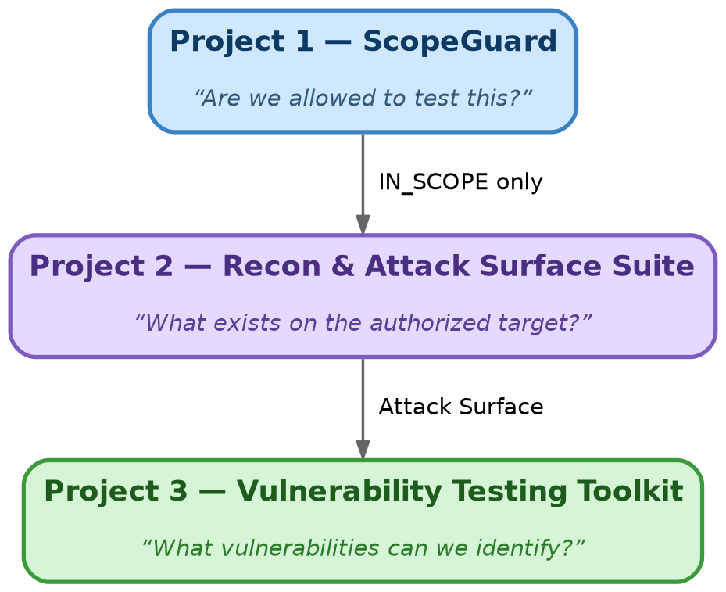
Figure 1: Each project in the chain answers one question, and only one.
Project 2 never decides on its own whether a target is authorized — that decision belongs entirely to Project 1. Project 2's rule is strict and simple:
- IN_SCOPE → continue with reconnaissance
- OUT_OF_SCOPE → stop
- UNKNOWN → stop
- CONFLICT → stop
This means Project 2 inherits the same fail-closed philosophy as ScopeGuard: if authorization isn't clearly confirmed, nothing runs. Right now, this connection point (the ScopeGuardAdapter) is intentionally left as a placeholder in the configuration, so that simply running Project 2 with default settings can never accidentally authorize a real target.

3. The Full Recon Pipeline
Rather than being one giant script, Project 2 is organized as seven clear stages, each responsible for one part of building the picture. Data flows through them in order, and each stage only adds information — it never guesses or assumes something that hasn't actually been observed.
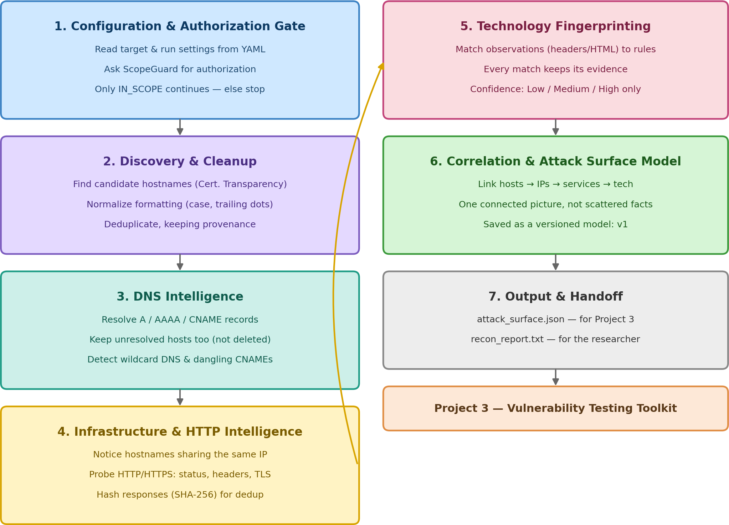
Figure 2: The seven stages of the Project 2 pipeline, from configuration to handoff.

3.1 Configuration & the Authorization Gate
Everything starts with a YAML configuration file describing the target, its type, and how the run should behave (for example, active vs. passive mode, explained later). Before a single network request is made, Project 2 checks in with ScopeGuard. No confirmed authorization means no reconnaissance — full stop.
target:
value: "example.com"
type: "DOMAIN"

execution:
mode: "active"

3.2 Discovery & Cleanup
Once authorized, Project 2 looks for candidate hostnames. In V1, the main source is Certificate Transparency (CT) logs — a public record of certificates issued for a domain, which often reveals subdomains a company didn't intend to advertise.
Raw discovery data is messy: the same host might appear as “WWW.Example.COM.” in one place and “www.example.com” in another. Project 2 normalizes these into one canonical form, then deduplicates them — while still remembering exactly which source(s) each discovery came from. This record-keeping is called provenance, and it matters because a finding backed by two independent sources is more trustworthy than one from a single source.

3.3 DNS Intelligence
Discovered hostnames are then resolved through DNS to find their A, AAAA, and CNAME records. Importantly, if a hostname doesn't resolve, Project 2 does not simply throw it away — an unresolved or timed-out hostname is still useful information, so it's recorded with a clear status (RESOLVED, UNRESOLVED, TIMEOUT, or ERROR) rather than silently disappearing.
Two specific DNS patterns are worth calling out, because they're common real-world findings in bug bounty programs:
- Wildcard DNS — when many random, made-up subdomains all resolve to the same address, that's usually a sign of a wildcard DNS record, not real discovered assets. Project 2 detects this pattern and lowers confidence in those results rather than treating them as genuine findings.
- Dangling CNAMEs — when a CNAME record points to an external service that's no longer active, that can be a serious security issue (subdomain takeover). Project 2 only flags this as a POTENTIAL_DANGLING_CNAME — it never tries to confirm or exploit it, since that's explicitly Project 3's job.

3.4 Infrastructure & HTTP Intelligence
Project 2 also looks at relationships between hosts — for example, noticing that three different subdomains all resolve to the same IP address (shared-IP awareness), which can hint at shared infrastructure.
For each live host, Project 2 probes HTTP and HTTPS and records what it observes: status codes, response headers, redirects, content type, and basic TLS details. To avoid storing or comparing huge amounts of raw response data, each response is reduced to a SHA-256 hash — if two hashes match, the underlying responses were identical, which is a fast and reliable way to spot duplicate content across many hosts.

3.5 Technology Fingerprinting
Using the observations gathered above (headers, cookies, HTML content), Project 2 tries to identify what technology each host is likely running — web servers, frameworks, content management systems, and so on.
Figure 3: Every technology guess is tied to the evidence that produced it.
Critically, Project 2 never claims certainty. Every match is recorded with a confidence level — Low, Medium, or High — along with the specific evidence that led to that conclusion. This mirrors the same philosophy from ScopeGuard's explainable decisions: a claim without a reason isn't trustworthy, no matter how confident it sounds.

3.6 Correlation & the Attack Surface Model
This is where everything comes together. Instead of leaving discoveries as separate, disconnected facts, Project 2 links them into one connected structure: which host resolves to which IP, which IP hosts which service, which service exposes which endpoints, and what technology each one appears to run.
The result is saved as a versioned structure called the Attack Surface Model, currently at version 1 (v1). Versioning this model matters because Project 3 depends entirely on its shape — if the structure changes later, giving it a version number means that change is visible and intentional, not a silent breaking change.

3.7 Output & Handoff
Finally, Project 2 produces two outputs from the same underlying data:
- attack_surface.json — a machine-readable file that Project 3 reads automatically to decide what to test next
- recon_report.txt — a plain-language summary for the human researcher to review

4. A Concrete Walkthrough
Here's what actually happens, step by step, if a researcher points Project 2 at an authorized target like example.com:
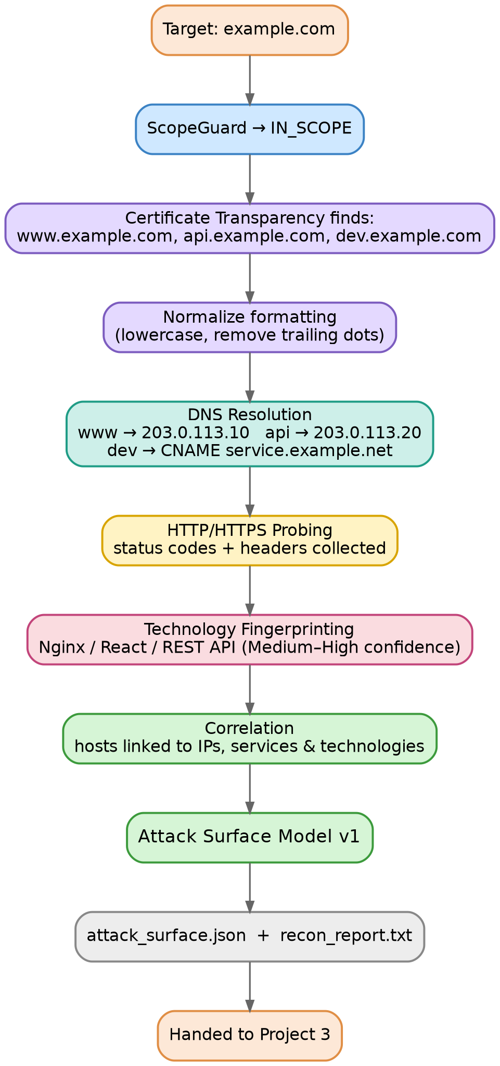
Figure 4: A single target flowing through the entire Project 2 pipeline.

5. Why Observation and Interpretation Are Kept Separate
A recurring idea throughout Project 2's design is that raw facts (observations) and conclusions drawn from them (interpretations) are always kept distinct, and every interpretation is paired with a confidence level.
Why this matters:
“The response header says X” is a fact. “This server likely runs X” is a conclusion. Blurring the two together — and reporting the conclusion as if it were a fact — is how false findings end up in bug bounty reports. Keeping them separate makes every result checkable.
This same discipline shows up in wildcard DNS detection (a repeated pattern is an observation; “this might not be a real subdomain” is the interpretation), and in dangling CNAME detection (an unresolving CNAME is an observation; “this might be takeover-able” is a flagged possibility, never a confirmed exploit).

6. Keeping the Target Safe: Execution Modes & Politeness
Because Project 2 is the first project in the series that actually talks to live infrastructure, it needs to be considerate of the systems it's scanning — not just authorized to scan them.

6.1 Active vs. Passive-Only Mode
Project 2 supports two modes. Active mode allows the fuller set of V1 activities (including live HTTP/HTTPS probing). Passive-only mode restricts the run to passive discovery sources, useful when a researcher wants information without directly interacting with the target's live services beyond what passive discovery requires.

6.2 Politeness & Rate Limiting
All active requests pass through a politeness controller that limits concurrency, paces requests per second, and enforces timeouts — so Project 2 behaves like a careful researcher, not a flood of traffic.
politeness:
concurrency: 5
requests_per_second: 2
timeout_seconds: 10

7. How the Project Is Built
Project 2 follows the same small-pieces-that-each-do-one-job philosophy as ScopeGuard. The components map roughly onto the pipeline stages described above:
Component | What It's Responsible For
authorization | Talks to ScopeGuard and enforces the fail-closed rule
config | Reads and validates the YAML run configuration
providers | Collects raw data: discovery, DNS, infrastructure
processing | Interprets raw data (normalization, fingerprinting, correlation)
pipeline | Controls execution order, stage status, and shared state
policy | Governs authorization, active/passive mode, and politeness limits
models | Defines the shared data structures used throughout
output | Produces the JSON file and the human-readable report
schemas | Defines and versions the Attack Surface Model structure
cli | The command-line interface a researcher actually runs

This separation between providers (collecting) and processing (interpreting) is intentional — it means a new discovery source can be added later without touching the logic that interprets results, and vice versa.

8. Testing
Project 2 is backed by a genuinely thorough automated test suite, covering discovery, DNS analysis, infrastructure detection, fingerprinting, correlation, output generation, and the CLI itself — organized into unit tests, component tests, pipeline integration tests, and full application integration tests.
At the latest verification point, the suite included 406 passing tests, plus 11 CLI tests and 4 application integration tests — a level of test coverage that goes well beyond what most portfolio projects at this stage typically include, and is worth highlighting explicitly to anyone reviewing the project.

9. What's In V1, and What's Deliberately Left Out

Included in V1
- Certificate Transparency-based passive discovery
- Hostname normalization and deduplication with provenance tracking
- DNS resolution, wildcard DNS detection, and dangling CNAME flagging
- Shared-IP infrastructure awareness
- HTTP/HTTPS probing with response hashing
- Evidence-based technology fingerprinting with confidence levels
- A versioned, correlated Attack Surface Model (v1)
- JSON and human-readable report output
- Active and passive-only execution modes, with built-in rate limiting

Intentionally NOT in V1
- Exploiting anything — SQLi, XSS, SSRF, auth attacks, brute force, and similar
- Confirming a dangling CNAME as an actual takeover
- Full port scanning or aggressive active scanning (e.g. Nuclei-style scanning, WAF bypass)
- Complete cloud-provider enumeration (only lightweight categorization)
Project 2's only job is to build an accurate, well-evidenced map. Everything involving actually testing for weaknesses belongs to Project 3.

10. How Project 2 Hands Off to Project 3
Project 2 is the map. Project 3 is the investigation. Project 2 answers “where should we look?” — Project 3 answers “what security weaknesses can we find there?”
Because the Attack Surface Model is versioned and structured, Project 3 can consume it automatically: reading the discovered endpoints, the fingerprinted technologies, and the flagged indicators (like potential dangling CNAMEs) to decide exactly which vulnerability checks are relevant — instead of blindly running every possible test against every host.

11. Key Takeaway
The one idea to remember:
Project 2 does not attack the target — it builds a clear, evidence-backed map of it, so that later security testing can be performed in a controlled and informed way, rather than guessing blindly.
Just as ScopeGuard's discipline was refusing to guess about authorization, Project 2's discipline is refusing to guess about facts — every discovery keeps its source, every technology guess keeps its evidence and confidence, and nothing is ever silently deleted just because it didn't resolve cleanly. That consistency of principle across projects is what makes Hunt_Chain read as one coherent system rather than a pile of separate scripts.

